**A COMPLETE REPORT**

**ON**

**THE ANALYSIS OF PUMPKIN PLANTS**

**General Testing Procedure:**

$H_{0}:$**(null hypothesis):** There is no significant difference in the average values of the parameter under consideration in plants in the control group and the treated group.

$H_{1}:$**(alternate hypothesis):** The average value of the parameter under consideration is significantly higher in plants in the treated group, than the control group.

**Level of significance (l.o.s):** 0.05

**Critical Region**: Reject $H_{0}$ at 0.05 l.o.s iff computed p-value < 0.05.

**Outline of the analysis:**

* For the given data, we have first plotted the means week-wise for both treatment and control for visual comparison. A linear trend has been fitted for both (which has been shown in the graph on the right-side of the panel for each parameter), that is, we assume that the parameter under consideration increases **linearly with time**. The linear equations reflect the change in the value of the parameters with time in an ideal situation, i.e., excluding the effect of irregular factors. Multiple $R^{2}$ values are reported in percentage for each fitting. Higher the $R^{2}$ value, better is the linear fit.
* Then, tests have been carried out **week-wise** to study the differences between the control and treated group of plants for each parameter. We have opted for **two** tests, one **parametric** (Student’s t-test), and the other **non-parametric** (Wilcoxon’s rank-sum test). The p-values and the decisions of the tests have been tabulated for each parameter. The lower is the p-value, the more difference in the parameter between the treated and controlled groups is suggested by the data.
* The decision of any statistical testing procedure is conventionally made **with respect to the null hypothesis $H_{0}$**  **.** “Accept” refers to accepting $H_{0}$, i.e., we conclude that in the light of the given data, there is no significant difference between the average values of the parameter under consideration in the control group and the treated group, whereas “Reject” refers to rejecting $H_{0}$**,** i.e., we conclude that in the light of the given data, the value of the parameter under consideration is significantly higher in the treated group of plants than in the control group of plants.

**Parameters:**

1. Plant length
2. Number of leaves
3. Number of nodes
4. Leaf length
5. Leaf width
6. Number of tendrils
7. Number of buds
8. Number of Flowers
9. Number of Fruits
10. Tendril Length

**Analysis:**

1. **Plant length**

**Graphs:**

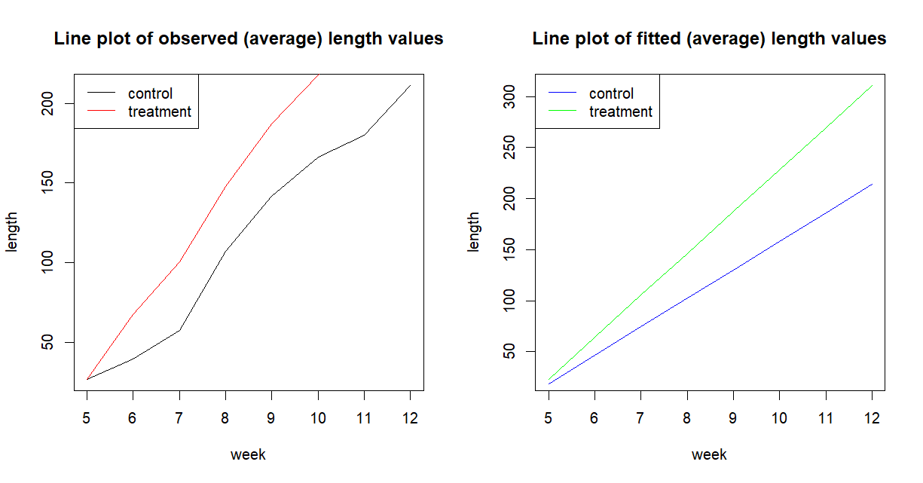

**Fitted equations:**

| **GROUP** | **FITTED LINEAR EQUATION** | **(MULTIPLE) $R^{2 }$ VALUES** |
| --- | --- | --- |
| CONTROL | -9.763 + 28.006*t  t = 1(1)8 | 98.02% |
| TREATED | -17.862 + 41.045*t  t = 1(1)8 | 99.53% |

**Test results:**

| **WEEK** | **t-TEST P VALUE** | **DECISION** | **WILCOXON P VALUE** | **DECISION** |
| --- | --- | --- | --- | --- |
| 5 | 0.5116957 | Accept | 0.6112 | Accept |
| 6 | 0.002181404 | Reject | 0.005553 | Reject |
| 7 | 0.003109751 | Reject | 0.00741 | Reject |
| 8 | 0.06102977 | Accept | 0.1092 | Accept |
| 9 | 0.03508167 | Reject | 0.05647 | Accept |
| 10 | 0.02139207 | Reject | 0.04057 | Reject |
| 11 | 0.001965804 | Reject | 0.003275 | Reject |
| 12 | 0.00004783904 | Reject | 0.0003549 | Reject |

**Interpretations:**

* From the **plots** (both observed and fitted), we observe that the average length of the plants for the treated group is higher than that of the control group for all the weeks.
* Additionally, from the **fitted linear equations**, we can say that the rate of increase of length of plants in the treated group is higher than that of the control group, as indicated by the slope coefficients of the fitted lines.
* Both the **testing procedures** also indicate that the average length of the plant is almost always consistently higher for the treated group, compared to the control group, except for the 5th, 8th week for both tests, and the 9th week for Wilcoxon’s test only.
* The possible reason for no significant difference in the 5th week may be since the treatment was administered to the plant in the 5th week itself.

1. **Number of leaves**

**Graphs:**

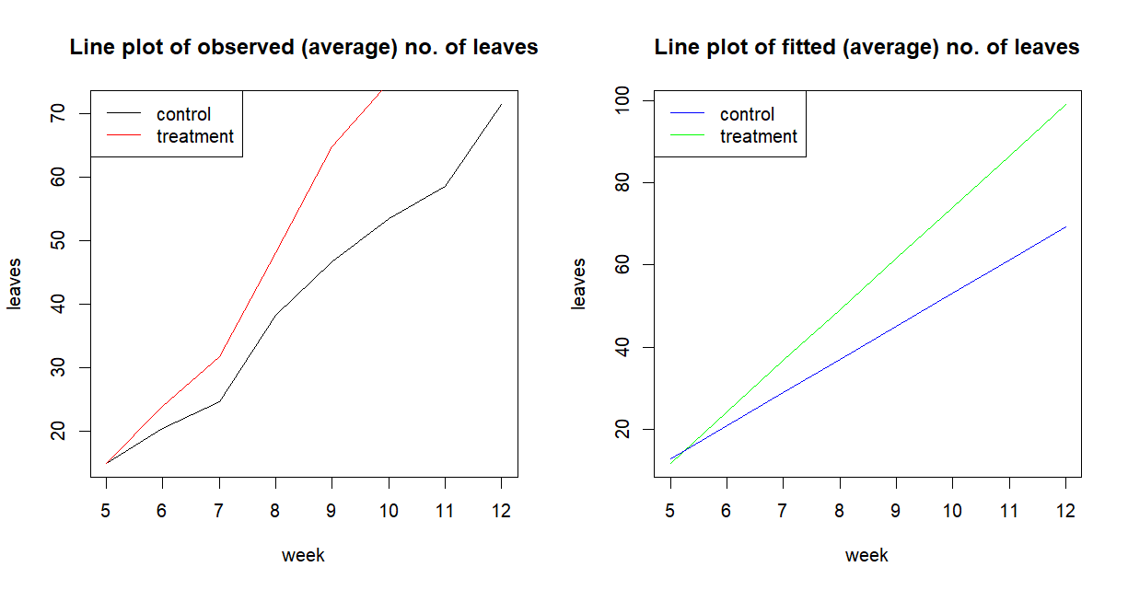

**Fitted equations:**

| **GROUP** | **FITTED LINEAR EQUATION** | **(MULTIPLE) $R^{2 }$ VALUES** |
| --- | --- | --- |
| CONTROL | 4.6071 + 8.0980*t  t=1(1)8 | 98.61% |
| TREATED | -0.6868 + 12.4625*t  t=1(1)8 | 99.08% |

**Test results:**

| **WEEK** | **t-TEST P VALUE** | **DECISION** | **WILCOXON P VALUE** | **DECISION** |
| --- | --- | --- | --- | --- |
| 5 | 0.5 | Accept | 0.7056 | Accept |
| 6 | 0.105690833 | Accept | 0.1292 | Accept |
| 7 | 0.024833498 | Reject | 0.02251 | Reject |
| 8 | 0.148369121 | Accept | 0.2603 | Accept |
| 9 | 0.047181638 | Reject | 0.0651 | Accept |
| 10 | 0.027425244 | Reject | 0.05034 | Accept |
| 11 | 0.006799655 | Reject | 0.002387 | Reject |
| 12 | 0.003538430 | Reject | 0.001126 | Reject |

**Interpretations:**

* From the **plots** (both observed and fitted), we observe that the average number of leaves of the plants for the treated group is higher than that of the control group for all the weeks.
* Additionally, from the **fitted linear equations**, we can say that the rate of increase of number of leaves of plants in the treated group is higher than that of the control group, as indicated by the slope coefficients of the fitted lines.
* Both parametric (t-test) and non-parametric (Wilcoxon’s rank-sum test) **testing procedures** indicate that the average number of leaves of the plant for the treated group is almost always consistently higher compared to the control group, except for the 5th and 6th week for both tests, and 9th and 10th week for Wilcoxon’s test only. The differences in the results of the t-test and Wilcoxon’s test are due to marginal differences in the p-values (about the value 0.05) computed in both procedures.
* The possible reason for no significant difference in the 5th week may be since the treatment was administered to the plant in the 5th week itself.

1. **Number of nodes**

**Graphs:**

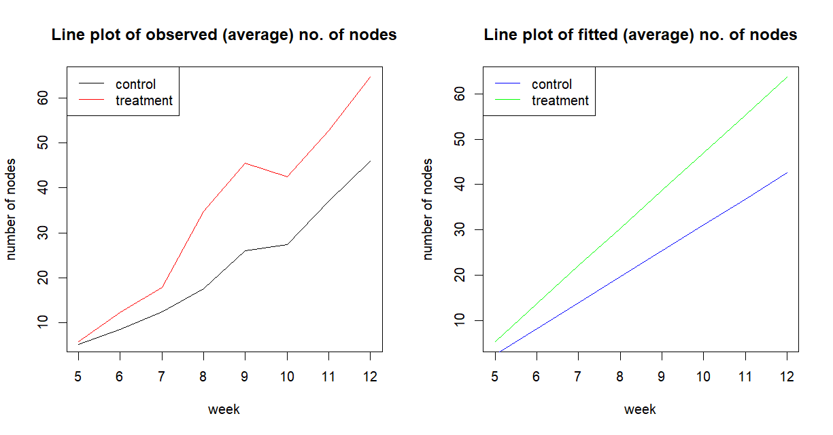

**Fitted equations:**

| **GROUP** | **FITTED LINEAR EQUATION** | **(MULTIPLE) $R^{2 }$ VALUES** |
| --- | --- | --- |
| CONTROL | -3.2582 + 5.7262*t  t=1(1)8 | 97.19% |
| TREATED | -2.9066 + 8.3168*t  t=1(1)8 | 96.19% |

**Test results:**

| **WEEK** | **t-TEST P VALUE** | **DECISION** | **WILCOXON P VALUE** | **DECISION** |
| --- | --- | --- | --- | --- |
| 5 | 0.219475483 | Accept | 0.25 | Accept |
| 6 | 0.001367694 | Reject | 0.002408 | Reject |
| 7 | 0.001387608 | Reject | 0.002277 | Reject |
| 8 | 0.003513790 | Reject | 0.0064 | Reject |
| 9 | 0.011604460 | Reject | 0.00741 | Reject |
| 10 | 0.033979636 | Reject | 0.02126 | Reject |
| 11 | 0.052483028 | Accept | 0.065 | Accept |
| 12 | 0.030230997 | Reject | 0.03051 | Reject |

**Interpretations:**

* From the **plots** (both observed and fitted), we observe that the average number of nodes of the plants for the treated group is higher than that of the control group for all the weeks.
* Additionally, from the **fitted linear equations**, we can say that the rate of increase of number of nodes of plants in the treated group is higher than that of the control group, as indicated by the slope coefficients of the fitted lines.
* Both parametric (t-test) and non-parametric (Wilcoxon’s rank-sum test) **testing procedures** indicate that the average number of leaves of the plant for the treated group is almost always consistently higher than that of the control group, except for the 5th and 11th week.
* The possible reason for no significant difference in the 5th week may be since the treatment was administered to the plant in the 5th week itself.

**4. Leaf Length**

**Graphs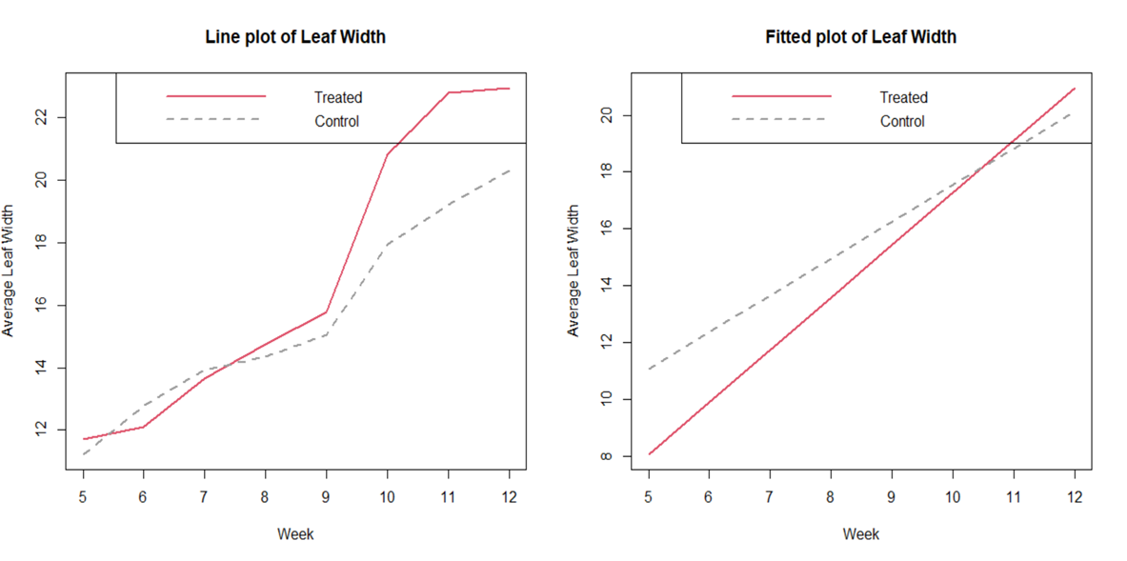INTERPRETATION**

1) From the fitted plot of Leaf Length, the treated group is higher, which indicates higher rate of increase of leaf length in the treated group

2) From both the plot of observed and fitted leaf width, it seems that although there is an increase in leaf length after application of the treatment but the increase is not so significant.

**TIME SERIES ANALYSIS - FITTED LINEAR EQUATION**

| **TREATMENT** | **FITTED LINEAR TREND EQUATION (ON WEEKLY AVERAGES)** | **MULTIPLE (R-SQUARED)**  **VALUES** |
| --- | --- | --- |
| TREATED | −1.9883+1.9174×t | 0.9234 |
| CONTROL | 0.4077+1.6269×t | 0.9406 |

**t-TEST AND WILCOXON RANK SUM TEST RESULT**

| **WEEK** | **t TEST $ p- VALUES** | **DECISION** | **WILCOXON TEST $ p - VALUES** | **DECISION** |
| --- | --- | --- | --- | --- |
| 5 | 0.6277 | ACCEPT | 0.7566 | ACCEPT |
| 6 | 0.9737 | ACCEPT | 0.9702 | ACCEPT |
| 7 | 0.7967 | ACCEPT | 0.8561 | ACCEPT |
| 8 | 0.7979 | ACCEPT | 0.7078 | ACCEPT |
| 9 | 0.5416 | ACCEPT | 0.5522 | ACCEPT |
| 10 | 0.1471 | ACCEPT | 0.1515 | ACCEPT |
| 11 | 0.08395 | ACCEPT | 0.08582 | ACCEPT |
| 12 | 0.3713 | ACCEPT | 0.4077 | ACCEPT |

**INTERPRETATION:**

Both t-test and Wilcoxon Rank-Sum test indicate that there seems no significant difference in the length of leaf in the control and treated group throughout the 8 weeks of observation.

**5. LEAF WIDTH**

**Graphs**

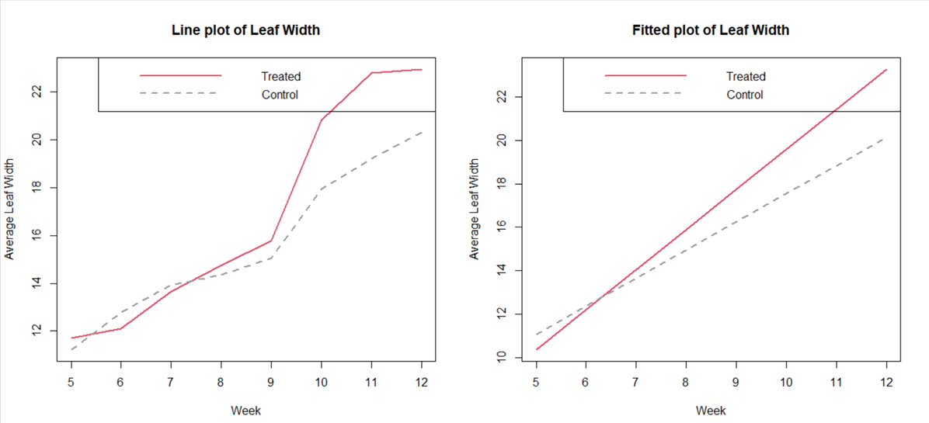

**INTERPRETATION**

1) From the fitted and observed plot of Leaf Width, the slope of treated group is higher indicating higher rate of increase in leaf width of the treated group.

2) From the observed plot,It seems that there is an increase in the width of leaf due to treatment in the first 4-5 weeks of application, although not significantly.

3) Significant increase in width of leaf is observed in both the fitted and observed plot from 10th week onwards.

**TIME SERIES ANALYSIS-FITTED LINEAR TREND EQUATION**

| **TREATMENT** | **FITTED LINEAR TREND EQUATION (ON WEEKLY AVERAGES)** | **MULTIPLE (R-SQUARED) VALUES** |
| --- | --- | --- |
| TREATED | 1.1536+1.8431×t | 0.9304 |
| CONTROL | 4.60842+1.29267 | 0.9675 |

**t-TEST AND WILCOXON RANK- SUM TEST RESULT**

| **WEEK** | **t TEST $ p- VALUES** | **DECISION** | **WILCOXON TEST $ p - VALUES** | **DECISION** |
| --- | --- | --- | --- | --- |
| 5 | 0.28735 | ACCEPT | 0.3984 | ACCEPT |
| 6 | 0.80106 | ACCEPT | 0.9225 | ACCEPT |
| 7 | 0.64697 | ACCEPT | 0.8181 | ACCEPT |
| 8 | 0.35826 | ACCEPT | 0.3596 | ACCEPT |
| 9 | 0.22365 | ACCEPT | 0.2763 | ACCEPT |
| 10 | 0.01516 | REJECT | 0.01263 | REJECT |
| 11 | 0.00426 | REJECT | 0.00686 | REJECT |
| 12 | 0.01438 | REJECT | 0.01691 | REJECT |

**INTERPRETATION**

Based on the t-test and Wilcoxon Rank Sum test, it seems that the treatment doesn’t significantly affect the width of the leaves initially. It starts affecting the width of the leaves from 10th week onwards. Thus, the treatment results in significant increase in the width of leaves after 5 weeks of application.

**6. No. of Tendrils**

**Graphs**

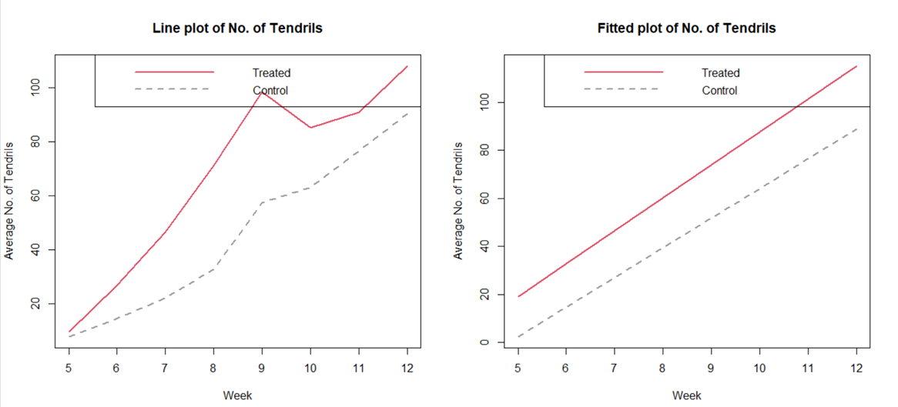

**INTERPRETATION**

1) From the observed and fitted plot, it seems that the no. of tendrils increases significantly due to the treatment over the 8 weeks of observation.

2) The peak is observed around 9-10 weeks in the observed plot, after which the tendrils fall, still giving a better result on treated plants.

**TIME SERIES ANALYSIS-FITTED LINEAR TREND EQUATION**

| **TREATMENT** | **FITTED LINEAR TREND EQUATION (ON WEEKLY AVERAGES)** | **MULTIPLE (R-SQUARED)VALUES** |
| --- | --- | --- |
| TREATED | -49.598+13.730 × t | 0.8868 |
| CONTROL | -59.2198+12.3324 × t | 0.9792 |

**t-TEST AND WILCOXON RANK-SUM TEST RESULT**

| **WEEK** | **t TEST $ p- VALUES** | **DECISION** | **WILCOXON TEST $ p - VALUES** | **DECISION** |
| --- | --- | --- | --- | --- |
| 5 | 0.17426 | ACCEPT | 0.1624 | ACCEPT |
| 6 | 0.001737 | REJECT | 0.0017 | REJECT |
| 7 | 0.00749 | REJECT | 0.00297 | REJECT |
| 8 | 0.02153 | REJECT | 0.01649 | REJECT |
| 9 | 0.03928 | REJECT | 0.02874 | REJECT |
| 10 | 0.03838 | REJECT | 0.0323 | REJECT |
| 11 | 0.13106 | ACCEPT | 0.1648 | ACCEPT |
| 12 | 0.08689 | ACCEPT | 0.1239 | ACCEPT |

**INTERPRETATION:**

Based on the t-test and Wilcoxon Rank-Sum test, it seems that the number of tendrils increases significantly from week 6 to week 10 after providing the treatment. After 10th week, the treatment has no significant effect over control on on tendrils of the plant.

**7. No. of Buds:**

|  |  |
| --- | --- |

**values**

| Treated | 71.3% |
| --- | --- |
| Control | 75.48% |

| week | t test$pval | t test$ dec | wilcox$pval | wilcox$dec |
| --- | --- | --- | --- | --- |
| 5 | 0.0570276 | Accept | 0.05987 | Accept |
| 6 | 0.0010077 | Reject | 0.001901 | Reject |
| 7 | 0.0048669 | Reject | 0.005491 | Reject |
| 8 | 0.0035314 | Reject | 0.002379 | Reject |
| 9 | 0.0084649 | Reject | 0.003021 | Reject |
| 10 | 0.0022486 | Reject | 0.005153 | Reject |
| 11 | 0.0039057 | Reject | 0.003499 | Reject |
| 12 | 0.0257654 | Reject | 0.01758 | Reject |

**Interpretations:**

* Both plots of observed and fitted mean values indicate that the increase in number of buds seems to be more when the plants are treated with the treatment than that of the control plants.
* The plot of linearly fitted mean values reveal that the rate of increase in number of buds over time (slope parameter) is more in the treated group than that in the controlled group.
* Both t-test (parametric) and Wilcoxon Rank-sum test indicates that in light of the given data there is no significant difference in the no. of buds in the control group and the treated group initially, whereas the no. of buds becomes significantly higher in the treated group of plants than in the control group of plants as time progresses.

**8.** **No of Flowers:**

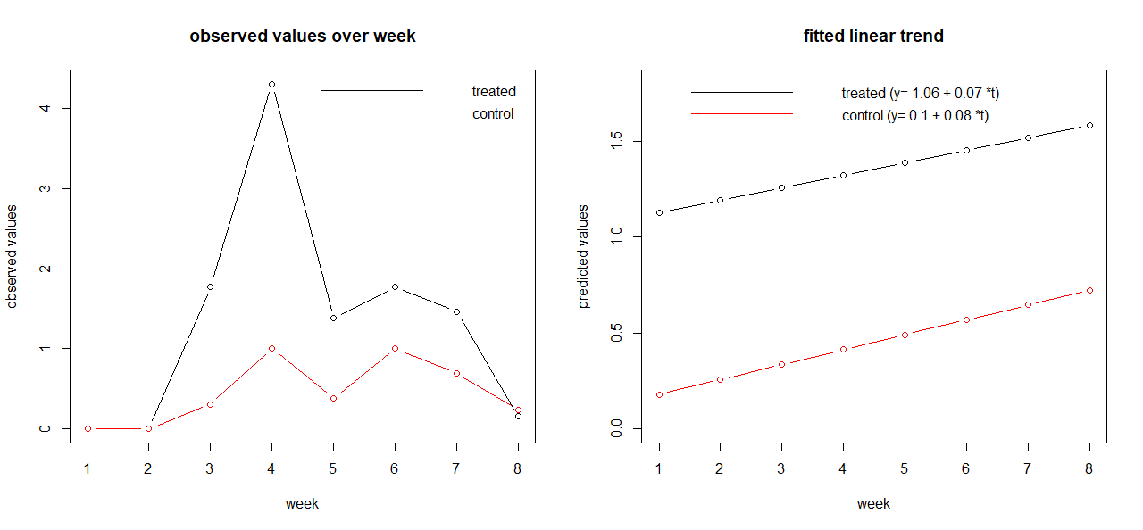

$R^{2 }$**values**

| Treated | 1.25% |
| --- | --- |
| Control | 22.3% |

| week | t test$pval | t test$ dec | wilcox$pval | wilcox$dec |
| --- | --- | --- | --- | --- |
| 5 | 1 | Accept | 1 | Accept |
| 6 | 1 | Accept | 1 | Accept |
| 7 | 0.025574 | Reject | 0.1048 | Accept |
| 8 | 0.002938 | Reject | 0.006385 | Reject |
| 9 | 0.006953 | Reject | 0.009714 | Reject |
| 10 | 0.031557 | Reject | 0.03537 | Reject |
| 11 | 0.020994 | Reject | 0.03652 | Reject |
| 12 | 0.682348 | Accept | 0.7004 | Accept |

**Interpretations:**

* The plot of observed mean values of number of flowers of treated and controlled plants reveal that the number of flowers first increases and then decreases in both the groups. But the rate of increase in the number of flowers over time in treated plants is much more than that in controlled plants.
* From the plot of observed mean values the trend present in both the time series (treated and controlled) seem not to be linear. The $R^{2 }$ values of the linear fit reveal the same. Hence no conclusion can be made from the fitted linear plots.
* Both t-test (parametric) and Wilcoxon Rank-sum test indicates that in light of the given data there is no significant difference in the no. of flowers in the control group and the treated group initially, whereas the no. of flowers becomes significantly higher in the treated group of plants than in the control group of plants as time progresses. It is also to be noted that since the number of flowers decreases in the end in both the groups, hence there is no significant difference in the no. of buds in the controlled group and the treated group in the 12th week.

**9.** **No of Fruits:**

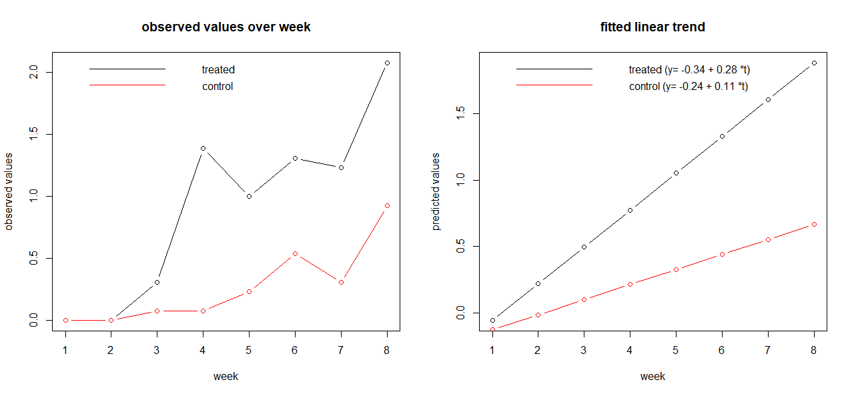

$R^{2 }$**values**

| Treated | 83.45% |
| --- | --- |
| Control | 75.02% |

| week | t test$pval | t test$ dec | wilcox$pval | wilcox$dec |
| --- | --- | --- | --- | --- |
| 5 | 1 | Accept | 1 | Accept |
| 6 | 1 | Accept | 1 | Accept |
| 7 | 0.119393 | Accept | 0.1438 | Accept |
| 8 | 0.0120373 | Reject | 0.002167 | Reject |
| 9 | 0.0854126 | Accept | 0.03315 | Reject |
| 10 | 0.1496273 | Accept | 0.6464 | Accept |
| 11 | 0.0458682 | Reject | 0.01953 | Reject |
| 12 | 0.0458682 | Reject | 0.04177 | Reject |

**Interpretations:**

* Both plots of observed and fitted mean values indicate that the increase in number of fruits is more when the plants are treated with the treatment than that of the control plants.
* The plot of linearly fitted mean values reveal that the rate of increase in number of fruits over time (slope parameter) is much more in the treated group than that in the controlled group.
* Both t-test (parametric) and Wilcoxon Rank-sum test indicates that in light of the given data there is no significant difference in number of fruits of the control group and the treated group initially, whereas tendril length becomes significantly higher in the treated group of plants than in the control group of plants as time progresses.

**10.** **Tendril Length**

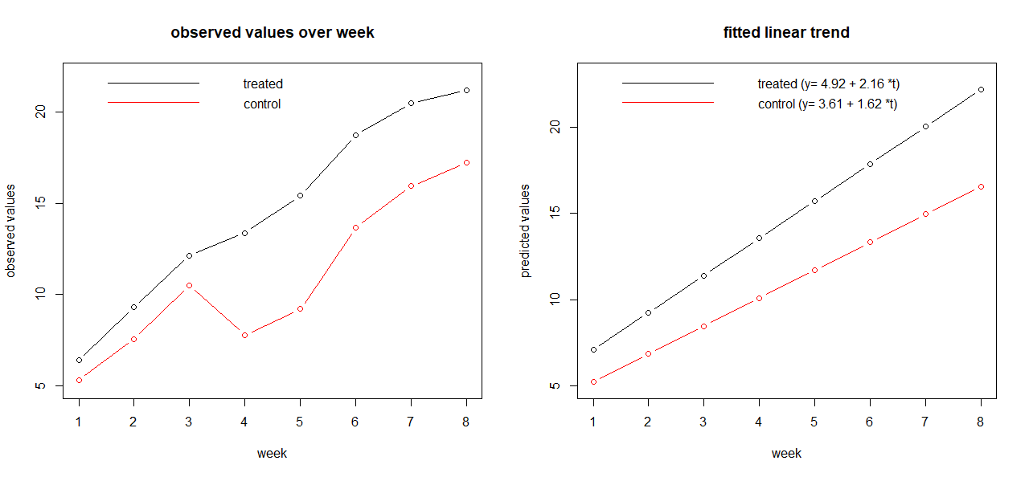

$R^{2 }$**values**

| Treated | 98.43% |
| --- | --- |
| Control | 86.14% |

| week | t test$pval | t test$ dec | wilcox$pval | wilcox$dec |
| --- | --- | --- | --- | --- |
| 5 | 0.19337270 | Accept | 0.2946 | Accept |
| 6 | 0.06600632 | Accept | 0.1024 | Accept |
| 7 | 0.19464930 | Accept | 0.2361 | Accept |
| 8 | 0.00022965 | Reject | 0.0007158 | Reject |
| 9 | 0.00000203 | Reject | 2.95E-05 | Reject |
| 10 | 0.00056936 | Reject | 0.002 | Reject |
| 11 | 0.00243620 | Reject | 0.004358 | Reject |
| 12 | 0.00822402 | Reject | 0.01981 | Reject |

**Interpretations:**

* Both plots of observed and fitted mean values indicate that the increase in tendril length (slope parameter) is more when the plants are treated with the treatment than that of the control plants.
* The plot of linearly fitted mean values reveal that the rate of increase in tendril length over time is more in the treated group than that in the controlled group.
* Both t-test (parametric) and Wilcoxon Rank-sum test indicates that in light of the given data there is no significant difference in tendril length of the control group and the treated group initially, whereas tendril length becomes significantly higher in the treated group of plants than in the control group of plants as time progresses.